Faculty of Science, Engineering and Technology





**Interface Design and Development**

Pass Task 5: Creating Module and Controllers

**Overview**

Module enables you to create modular codes for your web application. In this task you will create a status posting web application that uses controllers to insert a status into the timeline. As there is no persistent storage, the timeline will initially be empty. The latest status will always be displayed on top pushing down previous status. Each status will also contain a delete button that will enable the user to delete the specific status.

**Purpose:** Learn how to use module and practice on controllers.

**Task:** Create a web app that allows users to post status on a timeline, and each timeline will have its own delete button to delete the message.

**Time:** This task should be completed in your lab class and submitted for feedback before the start of week 7.

**Resources:**

* + - Lecture notes #3, #4 and #5

***Submission Details***

You must submit the following files to Blackboard:

* Status posting & Roman numeral source code (statpost.html).
* Status posting module and controller source code (appstatpost.js).
* Screenshot of the web app.

Make sure that your task has the following in your submission:

* The status posting web application is HTML5 compliant.
* Demonstrates understanding in using the AngularJS framework.
* Demonstrates use of AngularJS module and controllers.

**Instructions**

Implement the status posting web app. In this web application, you will need to use the controller to insert/delete a status into/from an array of status. Status is inserted as the first element of the array, while each status will have a button that allows it to be deleted.

1. Start by creating a new HTML file in Brackets.
2. Implement the basic outline of an AngularJS web app with the appropriate scripts.

**Note:** It is a good practice to write the controller in a separate file.

<script src="js/appstatpost.js"></script>

1. The HTML file will have
   * User input for the user to enter their status followed by a post button
   * Status view that shows the message posted followed by a delete button

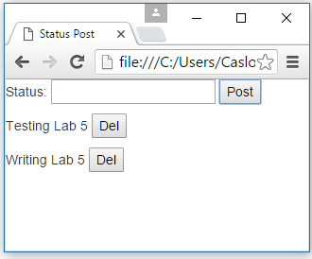

**Hint:** Use ngRepeat to list the status, which can be in a div, list or table. Use $index to identify which status to delete, by using it as a parameter for the delete method.

1. Create the module file appstatpost.js with the controller template.

Web App: **appstatpost.js**

————————————————

var app = angular.module("myApp", []);

app.controller ("myCtrl",

function ($scope){

:

<your code here>

}

);

1. Your web app should now be complete. Add comments in your coding and additional bootstrap styling. Make sure you test it on the browser to make sure that it works as you expect.